**Chapter 5 - Competition Design**

**Andrew Gordon, Ekaterina Levitskaya, Jonathan Morgan, Paco Nathan and Sophie Rand - New York University**

We hosted a competition to address the problem of automating information extraction from publications. The goal of the competition was to develop and identify the best text analysis and machine learning techniques to find datasets in empirical scientific publications and use that information to discover relationships between data sets, researchers, publications, research methods, and fields. The results were expected to help to create a rich context for empirical research – and build new metrics to describe data use. This is an open-source project, and we sought to generate models that could be continuously improved upon through engagement with the research community.

This paper describes how the competition was designed and discusses the lessons learned.

# Competition Design

The design approach followed the successful approach developed in the Natural Language Processing (NLP) domain, which developed a series of competition patterns for inspiring disparate groups of researchers to help to carry out information tasks against text data. These include more basic competitions where data is provided to groups and they are allowed to train and then submit a number of runs of their models against a subset of evaluation data[1]. We were also inspired by the design of the 2015 PatentsView Inventor Disambiguation Technical Workshop[2].

# Competition Design in Phases

The competition had two phases. In each of the two phases, competing teams were given text and metadata for 5,000 publications and single set of metadata on 10,348 data sets of interest, shared between the two phases, for use in training and testing their models. Separate 5,000-publication samples were provided for each phase. The corpus[3] included data maintained by Deutsche Bundesbank and the set of public data sets hosted by the Inter-university Consortium for Political and Social Research (ICPSR). In addition, a single 100-publication development fold was provided separate from the training and testing data to serve as a test for packaging of each team’s model, and as a quick test of their model and the quality of its output. After the first phase, the phase 1 holdout was also provided to phase 2 competitors to serve as additional training and testing data.

All publication text provided to teams was either open access (freely available) or licensed from the publisher for use in the contest. For each publication, participants were provided with PDF and plain text versions of each publication together with basic metadata. Copyright and licensing around research publications limited what publications could be accessed, licensed, and distributed for the competition, and so our universe of publications was limited to publications that were either open access, or published by Sage Publications.

At the end of each phase, competing teams packaged their models into a docker container. Then these containers were run on AWS by the competition organizers, evaluating the holdout data to generate predictions that were used to evaluate the teams.

## Phase 1

In the first phase, each publication was labeled to indicate which of the datasets from the master list were referenced within and what specific text was used to refer to each dataset. The teams used this data to train and tune algorithms to detect mentions of data in publication text and, when a data set in our list is mentioned, tie each mention to the appropriate data set.

The annotated portion of the two sets of publications were drawn from a set of publications provided by Bundesbank that referenced their data and the publications captured in the ICPSR catalog, which had been manually annotated as having used a particular data set for analysis. These publications were collected in a database application designed to facilitate a mix of human and automated content analysis of publications. They were then filtered into two sets: those that were open access, and so could be shared publicly, and those that were not open access, but that were available from our publisher partner (Sage Publications, or “Sage”). Of the 5,100 total publications with annotated data citations provided to phase 1 participants, the 2,550 publications in the train-test corpus (2,500) and development fold (50) were randomly selected from the open access set, so they could be distributed freely to all participants. The 2,500 in the holdout were randomly selected from the remainder of the open access set plus those available from Sage. The un-annotated publications used in phase 1 were all published by Sage: the 2,550 non-annotated publications in the train-test corpus (2,500) and development fold (50) were open access publications from Sage journals. The 2,500 un-annotated publications used in the holdout evaluation corpus were sampled from across Sage Publications’ journal holdings including non-open access journals.

Both the train-test publications and the holdout publications were broken into 2,500 publications each that used one or more of the data sets of interest for analysis, as compiled by ICPSR and Bundesbank staff, and 2,500 publications that had not been annotated and had been filtered to not contain data. The data set citations were captured in a separate data set citations JSON file. The citations for the phase 1 train-test publications were provided to competition teams to use as training data, while the citations in the phase 1 holdout were used to test the quality of each team’s model in phase 1, and given to teams as additional training data in phase 2.

Each team was allowed up to 2 test runs against the evaluation corpus before final submission. The final models of each group were evaluated against the holdout corpus, along with a random qualitative review of the mentions, methods, and fields detected by the team’s model. Submissions were primarily scored on the accuracy of techniques, the quality of documentation and code, the efficiency of the algorithm, and the quality and novelty of the methods and research fields inferred for each of the publications.

Four finalist teams were then selected to participate in the second phase, the teams from: Allen Institute for Artificial Intelligence, United States; GESIS at the University of Mannheim, Germany; Paderborn University, Germany; and KAIST in South Korea.

## Phase 2

In the second phase, finalists were provided with a new training corpus of 5000 unlabeled publications and asked to discover which of the datasets from the first phase’s data catalog were used in each publication, as well as infer associated research methods and fields. As in the first phase, teams were scored on the accuracy of their techniques, the quality of their documentation and code, the efficiency of their algorithm, and the quality and novelty of the methods and research fields inferred for each of the publications.

We worked with Sage to find publications in six key topic areas of interest for partners and future projects (Education, Health care, Agriculture, Finance, Criminal justice, and Welfare). For 28,769 matches, Sage provided PDFs for each and we parsed the text (see details below), removing any that did not parse, or that resulted in file sizes smaller than 20KB, reducing the size of the sample to 25,888. We looked at publication year and type to see if we needed to filter out older publications or non-academic publications, but there were few enough of each class (644 pre-2000 publications and 3,115 non-research articles) that we decided we’d keep all in to preserve as much potential for heterogeneity as possible. From these 25,888 publications, we then randomly selected a total of 10,000 with the goal to keep the distribution across the 6 topic areas equal (so 1666 randomly selected in 2 topic areas, 1667 randomly selected in the other 4). Then, we split the phase 2 corpus to give half to participants and keep half back for evaluation, maintaining equal distribution between the topic areas within each set of 5,000 publications.

# Operational Issues

## Converting PDF files

Plain text provided for each publication was derived from that publication’s PDF file by the competition organizers. It was not intended to be a gold standard, but to serve as an option in case a team preferred not to allocate resources to PDF parsing. Articles were converted from PDF to text using the open source “pdftotext” application. There are multiple drawbacks with this approach, such as losing many artifacts from PDF formatting, converting multi-column layouts to output text, and losing tables and chart information. Competition participants were encouraged to try their own conversion process if this text did not meet their needs, and if so we asked them to supply documentation so we could build a set of PDF processing strategies to reuse in the future.

## Data Sets

Competitors were provided with two sets of data related to detecting data sets: 1) a catalog of all of the data sets of interest that models were tasked with finding in publications, including basic metadata for all and a list of verbatim mention text snippets for those that were cited in the train-test data; and 2) a subset of these data sets that were actually specifically annotated as having been used for analysis in a given publication.

The data set catalog, provided to participants in the JSON file data_sets.json, contained metadata for all public datasets in the ICPSR data repository and a subset of public data sets available from Deutsche Bundesbank. It includes all data sets cited in the train-test and evaluation corpora, plus many others not cited in either.

A major challenge with the corpus development was that ICPSR captured when a given data set was used in analysis within a particular publication, but did not capture how that determination was made. To provide better data for participants, we implemented a human content analysis protocol to capture mention text for each data set-publication pair included in our train-test corpus. Since we manually created this data, given limited time and resources, we initially only did this work for data sets that the teams would be using for training and testing in phase 1. The list of data sets cited in a particular publication is also not exhaustive, because the ICPSR staff only tagged datasets that were ICPSR data and used in analysis.

### Data Set Mention Annotation Process

A long term goal is to facilitate the building of generalized models that are not overly dependent on the use of formal titles of data sets. We aim for models that know of and use the language of discussing and using data to recognize where data is discussed in a particular article and then identify which data sets. The ICPSR data contains many explicit ties between publications and data sets that would have been hard to come by otherwise, but the lack of any indication of which parts of the publication indicated the citation relationship made it difficult to identify the linguistic context within the publication that captured the relationship.

To make it easier for participants in the competition to efficiently and systematically engage with the language used to discuss data, we developed a content analysis protocol and accompanying web-based coding application so human coders could examine all of the data set citations in our train-test corpus and capture mention text for each. This required human workers to examine each data set citation in the context of its publication (there were X citations in 2500 training publications) to identify and mark locations in the text where each data set was referenced.

Because of the manual effort required, we only did this for the 2,500 train-test publications that referenced data provided to the teams. We did not manually annotate mention text in the 2,500 publications in the phase 1 holdout, and this made that data a little less useful for teams when it was given to them in phase 2.

Our team of coders was spread across the United States, and so we used a web-based application with a central database store to allow our distributed team of coders to work in parallel. The basic unit of work was a publication-data set pair (so a given publication would be examined as many times as it had different data sets cited within it).

The ICPSR data set repository is very fine-grained in definition of a data set, so each year of an ongoing survey, for example, might have its own data set. To save time, we eventually created the concept of a data set family for these types of data sets and assigned coding for any one instance in a family to all other instances from that family within a given publication. So, for example, multiple years of the same survey or longitudinal data collection were related to each other in a family, and then coding for one year within a paper was used for all other years cited in that paper.

The general process was as follows:

* each user was assigned a list of citations to code.
* Once the user logged in to the coding tool, they were presented with a list of the coding tasks assigned to them that included a status of each, so they could track which they had already completed, and a link for each to the coding page.
* Once the user loads a particular citation for coding, they are presented with the following coding page, and are asked to follow the coding instructions in the codebook/documentation for the annotation tool[4]

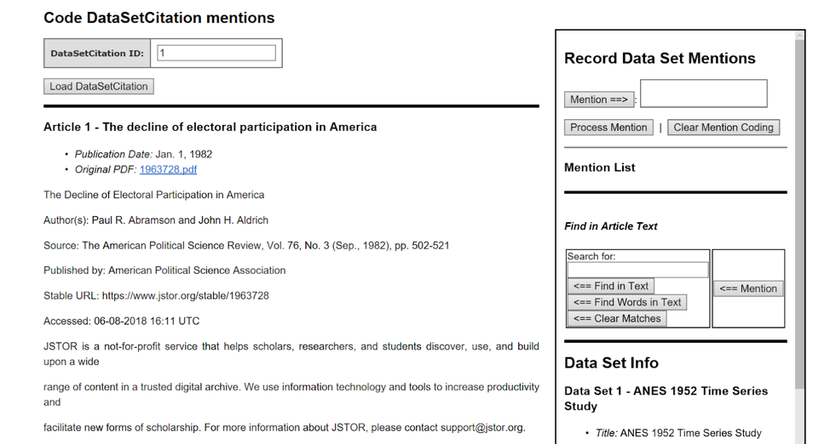

*Figure 1. Interface showing a publication and its related mention capturing.*

Coders were instructed to find terms that relate to mentions of the dataset and avoid general synonyms of those terms (for example, tagging “ANS survey” instead of only “survey”). If the phrase provides additional information about collection of the dataset, the mention is tagged twice. For example, in the case of “ANS survey collected/conducted by X”, “ANS survey” is captured first, and then “ANS survey collected/conducted by X”. At the same time, we tried to avoid including too much descriptive information of the dataset. The task is just to code the specific mentions of a particular dataset, including alternate names (e.g. abbreviations, etc.), rather than trying to capture full text in which the data set is discussed.

In total, a team of 5 coders, with a background in text analytics for policy research and computational linguistics, completed the task. The results were then used to re-render data_sets.json and the data_set_citations.json file for the phase 1 train-test data to include mentions.

This combined protocol and tool were developed in-house both because of time considerations and because some of the off-the-shelf text annotators and Qualitative Analysis tools such as lighttag.io, tag.works, NVivo, Atlas.ti, MAXQDA did not handle distributed workflows.

## Methods and Fields

For the task of detecting methods and fields for a given publication, our goals were broader than simply providing a vocabulary for each and asking the teams to classify publications against them. We want to encourage development of models that not only can figure out when a given publication is a part of an existing field or uses an existing method, but that also understand enough about fields and methods such that they can be used to detect new fields and methods as they emerge, and can then be used to look back through time for traces of these new fields and methods to track their growth and evolution.

We did not give any formal set of either methods or fields that participants needed to train models to classify from. Instead, we provided examples of taxonomies of methods and fields that Sage Publications uses to classify their publications, and we directed participants to use them as an example, but to try to make models that would be more creative and potentially able to find new, emerging, or novel fields rather than just fit a publication to a term from a predefined taxonomy. This decision to forego use of an existing taxonomy showed the complexity of the problem of understanding fields and methods well enough to detect them based on linguistic context. Some teams limited themselves to the vocabularies we defined, and the results were uninspiring. Some teams tried to detect based on text, but ended up with a lot of noise and few relevant terms.

In addition, we also learned that there is complexity in “methods” that lumping all methods together did not account for: methods could mean many things, and we started to find sub-categories that we wish we had broken this into: statistical methods, analysis methods, data collection and creation methods, etc.

For future work, for each of these types of information, we intend to first work to decide what exactly we mean by “fields” and “methods”, then find or develop one or more taxonomies to precisely capture what we mean. Once we have these taxonomies, we’ll focus separately on building models to classify publications to them, and making models to extend and update them.

## Developing a submission process

The submission process was designed to make it as straightforward and easy as possible for a team to package their model for submission, including minimizing the understanding needed to use technologies chosen for packaging and deployment and having a built-in way to automatically run the model over the dev fold to validate processing of standard input formats and creation of required output formats. We also wanted to minimize the installation and configuration work needed on part of competition organizers to replicate computing environments as part of model submission process and maximize our ability to see and be able to test how each submission environment is set up, and so avoid accepting a blackbox that could contain anything (including malicious code or sneaky/clever tricks). The git repository[5] was integral to our framework, but was not used directly by participants. Its code repository was solely used as a home for the code, scripts, and files that made up our submission framework.

Participants were instructed to work within the “project” folder in their work folder, get their code working first on their local machine, then set up a docker container using the provided example files and get the model running there, to isolate problems with docker from problems with their model. Participants were allowed 2 test submissions before the final submission, and most groups took us up on those test submissions in phases 1 and 2. All groups were able to work within the “code.sh” and “project.py” files in “project” to get their model to run, so no further customizations were needed.

## Running a Submitted Model

Once a model was submitted, the competition organizers followed a standard script for running the model and processing its output for analysis. Throughout this process, the evaluator communicated any problems with the participant team and worked with the team to address problems and turn around a new version of the model as quickly as possible. If a team’s model performed poorly on the standard size machine, we also would sometimes try different sizes of server to give them an idea of whether their problem was related to needing more compute power, or was a limitation of their approach independent of available resources.

# Evaluation

In both phases of the competition, we evaluated raw mentions, research fields, and research methods separate from citation of named data sets.

## Phase 1 Evaluation

### Mentions, Methods and Fields

In phase 1, expert social science judges evaluated mentions, methods, and fields in two ways: 1) we randomly selected 10 publications to manually examine each team’s output against, and made notes of good and bad for each team, then ranked the teams within each publication; and 2) we generated distributions of all values found across all publications within each type of value, counted the occurrences of each, compared the distributions across teams, and ranked the teams based on how their distributions compared. To create overall rankings, the judges met, compared notes and individual rankings, and then agreed on an overall ranking of the teams.

### Data Set Citations

To evaluate data set citations in phase 1, we used the ICPSR citation data as our evaluation baseline for creating a confusion matrix based on how each team’s citation findings compared to ICPSR’s baseline, and we calculated precision, recall, and F1 scores from the confusion matrix to compare across teams. To create the confusion matrix for each team, we started with a list of all of the data set-publication pairs found either in ICPSR’s baseline or the team’s output. We created found-or-not (1 or 0) vectors for every publication-data set pair for the baseline, and for the team. Then, for each data set-publication pair, we compared the values between the baseline vector and the team vector to decide how to update the confusion matrix for that pair: if a team agreed with ICPSR on presence of a data set, that was counted as a true positive (TP). If the team found a data set that ICPSR did not, that was counted as a false positive (FP). If a team missed a data set ICPSR indicated was present, it was counted as a false negative (FN). We did not develop a way to capture true negatives since the metrics we used to evaluate did not require it. In addition, as part of the processing to create the overall confusion matrix, we created per-publication confusion matrices for each publication, so we could track average false positives and false negatives per publication, and highlight publications that were higher than the average, for more detailed evaluation.

We also deferred figuring out “mentioned” vs. “used in analysis” in our initial competition, to make the initial task more manageable. This decision, combined with the traits of the ICPSR data, caused substantial noise in the phase 1 precision/recall/F1 scores. For example, even models that figured out that a longitudinal data set was present sometimes got many false positives and false negatives because they got the years wrong, and models that correctly found ICPSR data sets used in discussion had those counted as false positives because ICPSR had only captured data sets used in analysis.

## Phase 2 Evaluation

### Mentions, Methods and Fields

In evaluating phase 2, we kept the division between mentions, fields, and methods and citations, but we refined our evaluation methods based on what we’d learned in the first phase. We kept the basic strategy of: 1) comparing the values created by each team’s model in the context of a set of selected publications and 2) reviewing the overall distributions of values for each team.

We expanded the number of publications across which we compared values to make the sample reviewed more representative, though, and created a web-based tool to help judges deal with the added work from more publications to review. We also selected publications differently for data mentions from fields and methods, choosing publications with different levels of agreement between the teams on whether data was present or not, to start to evaluate the different model’s ability to detect data at all, in addition to comparing the results when they thought a publication contained data.

For fields and methods (and data set citations), we selected 20 publications for each of our 6 topic areas of interest (Education, Health care, Agriculture, Finance, Criminal justice, and Welfare) with a few extras (2 extra in finance and 1 extra in criminal justice), for a total of 123 publications to compare values across. Within the 20 publications per topic area, we worked through a random selection of articles picking publications to add to our sample to fill out a rough ratio within each topic area of 5:4:1 between publications with titled data sets (5); data described, but not titled (4); and no data (1).

To make it easier for the judges to work through this increased number of publications, we also created a tool that collected the output for each team side-by-side per publication along with a link to each publication’s PDF, and had a place for the judge to score each team’s output for a given publication from among “–1”, “0”, and “1”. Once judges scored all output, we then created rankings based on the sum of each team’s scores.

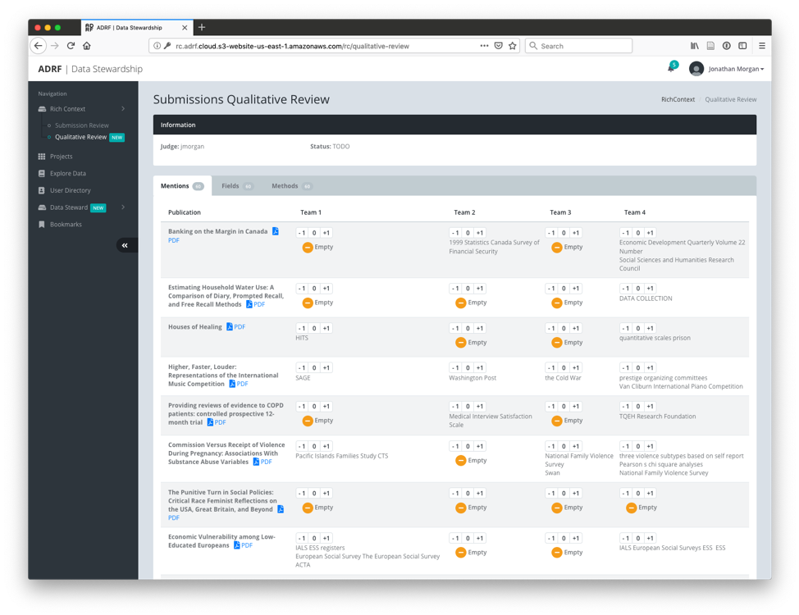

For manual evaluation of data set mentions, we used the same tool described above, but we chose a different sample of 60 publications based on agreement between the output of the different participant team models as to whether publications had data mentions. We then asked a separate pair of qualitative judges to use the tool to compare and evaluate the data set mentions generated by the teams across these publications.

### Data Set Citations

Our analysis of data set citations in phase 2 required a more substantial rethinking since we did not have any starting point for presence or absence of data like the ICPSR corpus. We implemented a method of creating a confusion matrix that could be used to generate precision, recall, and F1 scores more closely aligned with the task we’d assigned the teams to implement - finding mentions of data and data sets within publications.

To implement this, we started with the sample of 123 publications used for evaluating mentions and fields above and:

* Captured all “data references” within each of those publications using a new human coding protocol. This included external titled data sets either discussed or used in analysis, external data without a title that was discussed or used in analysis, and data created by the researcher for a given study.
* For each data reference, we compared all mentions and citations created by each team for the publication to the information on the data reference within that publication and marked any that were “related” to the data reference.
* Finally, we used the list of references as a baseline and built a confusion matrix based on whether each team had found mentions or citations “related” to each of the data references, along with a “false positive” record where the baseline was always 0 and the team was assigned a 1 if they had one or more mentions or citations that were not “related” to any data reference.

To capture data references in our sample of publications, we created a basic protocol for an initial round of data creation then evaluated the results throughout the rest of the process. We used a single data reference coder to encourage consistency in output. We tried to capture detailed context on each reference in order to make it easier for reviewers of this data to evaluate the quality of each data reference and to give more context for judges deciding if mentions and citations for a given team were “related” to a given data reference.

After the data references were captured, a team of coders then looked at each data reference related to the selected publications for each team to see if data set citations and mentions by the team were “related” to the data reference. The coders, subject matter experts in the different key topic areas, looked at each “data reference” in publications in their area of expertise. For each, they evaluated it against the mentions and citations output by the model of each team that found mentions or citations in the selected publication. For each reference-team pair, the coder flagged any mentions or citations they deemed “related to” the current data reference[6].

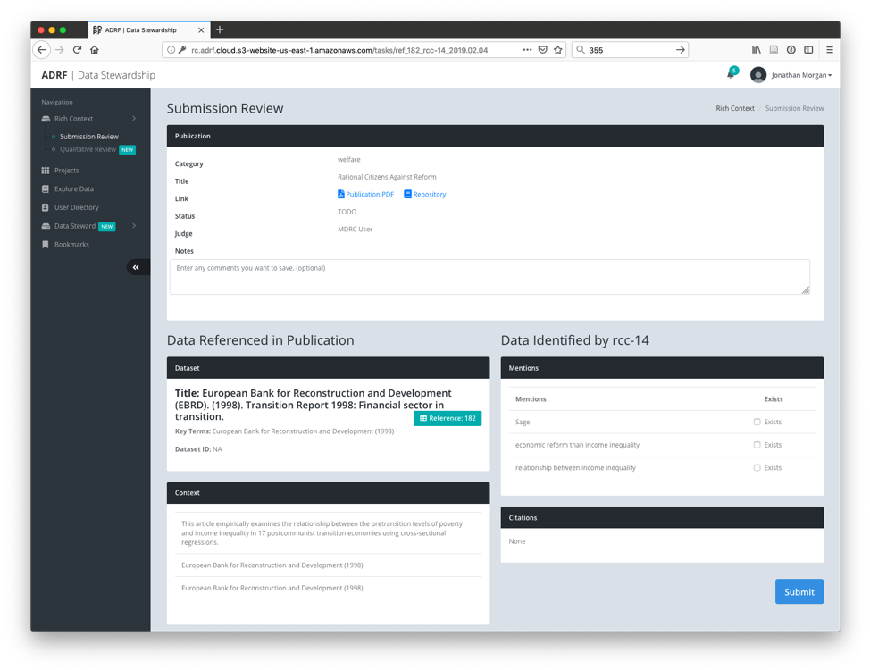As one would expect, while we got coders on the same page, each had subtly different ideas about what was or was not “related to”. To remove some of this variability from our final data, we then had a sole experienced researcher who understood what we were trying to do review all coding and, when he saw coding that obviously did not fit his understanding, either: revise to fit his understanding of “related to”; or flag as one he was unsure of and note his thoughts. This experienced researcher also served as a final reviewer of the data references that were collected, marking any that did not actually refer to data as needing to be removed from our final analysis. Finally, the protocol designer reviewed all removed data references, corrections, and ambiguities flagged for additional review, and made a final set of corrections.

## Scoring the Results

To create a “related to” confusion matrix for each team, we started with a list of all of the data references that our final reviewers indicated should be included in our analysis (165 total). We created found-or-not (1 or 0) vectors with a value for every reference set to 1 for the baseline, and then set based on our coding for each team. For each publication, we also included a false positive item that was always 0 for the baseline, and that was set to 1 for a given team if they had any mentions or citations that were not “related to” a data reference from that publication.

We did not develop a way to capture true negatives since the metrics we used to evaluate did not require it.

# Lessons learned

The docker-based model submission process worked well for competition, but subsequent use of the models by Digital Science and Bundesbank has shown that more precise design of how the models work within their docker container and the APIs they provide is necessary if packaged models are to be be used to produce reusable APIs. For example, to be readily able to be used within an existing environment, the model needs to be able to be invoked from a simple unit of code (a python function, for example), rather than needing to spin up an instance of a container each time you want results.

To facilitate re-use, we need much more detailed specification of how the participants should implement their models. For example:

* If a submission is implementing multiple tasks, each should be broken into its own separate API so it can be used separately (so separate services for mention detection, field detection, and data detection).
* We need to better specify how we expect the models to be re-trained, in particular elements of the model we expect to be easily changed and which we expect would require a full retraining to tune. For example, we hoped to be able to easily switch out the data sets of interest that are detected specifically without needing to retrain on a full corpus referring to those data sets, but we didn’t mention this, and none of the models worked this way.

We also learned that that while the data for the competition was an excellent starting point, it has some drawbacks. The base ICPSR data did not include mention text. It only identified ICPSR data that were used for analysis. Hence, for the majority of data sets, the only text available for characterizing a data set was the title and a paragraph of description with no examples of how the data would be discussed within a publication. A further drawback was that while data signatures of interest in the real world might just be clusters of key terms without a formal title, the competition data did not have that information.

We consider the competition design to have been effective. We got a good number of participants, the resulting models were interesting and some of the solutions were novel and surprisingly effective given their novelty, and discussions after the competition lead to collaborations between pairs of sponsors and participants and collective work on making a gold standard corpus that could be used to develop better models in the future (a great step toward higher quality models). The models also ended up being re-usable as they are, though in a limited scope, and Bundesbank has been able to run them and get output of high enough quality that it is useful to them.

There remains substantial work needed to move this effort forward, however. The next iteration of the competition is tentatively scheduled to begin at the end of 2020, and in this round, we are exploring options for building out a better corpus that combine manual, automated and crowd-sourced means of annotating data. We are working on a more standardized and carefully designed model packaging framework, to facilitate re-use. We are also working on more detailed specifications of model requirements (ability to retrain on data sets of interest without needing a whole new corpus of train-test data, for example).

*Jonathan Morgan designed and implemented the data annotation and evaluation strategies and the first draft of our model packaging framework. Andrew Gordon sampled and prepared the corpus for processing and for distribution to participants. Ekaterina Levitskaya helped with the design of refinement of coding protocols and did a substantial amount of the data annotation. Jonathan and Andrew worked together to collect and run submissions for the competition and summarize the output for the judges.*

1. Soboroff, I. M., Ounis, I., Lin, J., & Macdonald, C. (2013). Overview of the TREC–2012 Microblog Track. NIST Special Publication 500–298: The Twenty-First Text REtrieval Conference Proceedings (TREC 2012), 2012, 20. Retrieved from [https://www.nist.gov/publications/overview-trec–2012-microblog-track](https://www.nist.gov/publications/overview-trec%E2%80%932012-microblog-track)
2. See <http://www.patentsview.org/community/workshop-2015>
3. For details about the metadata provided for each type of data, see <https://github.com/Coleridge-Initiative/rich-context-competition/wiki/Dataset-Description>
4. For more details, including an FAQ that provides guidance on specific issues that arose during coding, e.g., how to handle data sets that span multiple years, see the content analysis protocol <https://docs.google.com/document/d/1xuZL_-z1re6TO3Sv8_9tdFk7z6ovyqTwDVgc1bYO3Ag/edit?usp=sharing>
5. <https://github.com/Coleridge-Initiative/rich-context-competition>
6. The protocol is described in <https://docs.google.com/document/d/1Hi13N6gfiRz9nfwCoUQrey8v_ozY7fKHMtHV4GgX2ys/edit>